Use the following apps in Odoo 16 localhost:

• **Contacts** → Create the customer

• **Sales** → Create and confirm the quotation → sales order

• **Inventory** → Process the delivery (if selling stockable products)

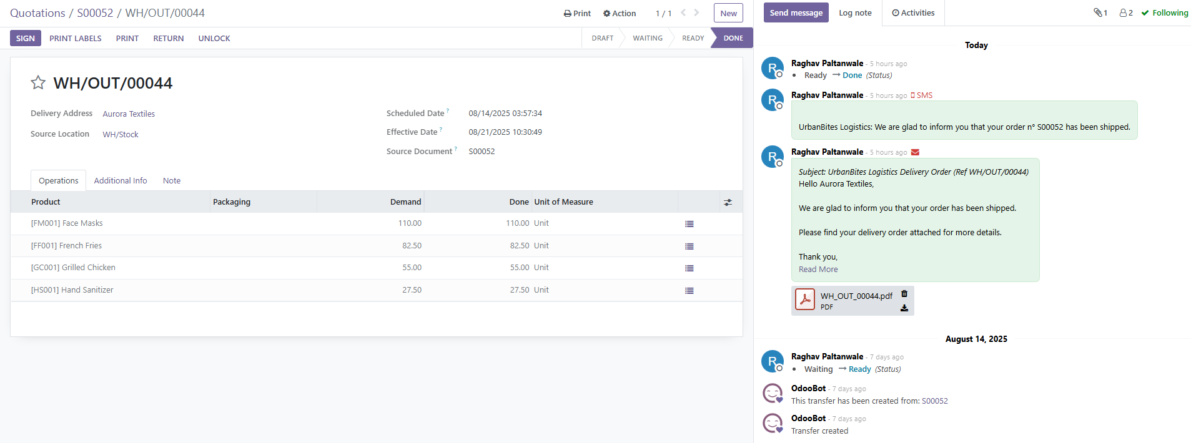

• **Invoicing** → Create and validate invoice

• **Invoicing** → Register payment

